SCRS/2018/xx

**PRELIMINARY PERFORMANCE EVALUATION OF CANDIDATE MANAGEMENT PROCEDURES THAT AIM FOR TARGET FISHING RATES AND INDICES (FBI) USING ABT MSE PACKAGE V3.3.2**

T Carruthers[1]

*SUMMARY*

*Simple constant (intended) proportion CMPs are applied to the 16 conditioned Operating Models (OMs) in version 3.3.0 of the Package. Ranges of the two control parameters for west and east proportions are selected to give reasonable trade-offs between catch and stock recovery (where needed). For nearly all of the OMs this is readily achieved. However, problems arise for some of the abundance factor B OMs (with lower west stock abundances matching those in the most recent assessment) coupled to an unchanging Beverton-Holt stock-recruitment function for the west stock (recruitment factor 2). For one of these scenarios, even with no catch from the west area, an already depleted west stock declines under catches in the east that are well below present levels, because sufficient bluefin of western origin migrate to the east area and can be harvested there. The key immediate question then becomes whether such OM scenarios are sufficiently plausible that they need to be taken into account when seeking an MP which evidences robustness over a range of reasonably plausible levels of uncertainty.*

*KEYWORDS*

*Management Strategy Evaluation, Candidate Management Procedure, Operating Model, Atlantic bluefin tuna, trade-off, plausibility*

**Introduction**

This paper extends the initial explorations of Butterworth et al. (2018) which aimed ultimately at developing Candidate Management Procedures (CMPs) for the (two mixing stocks of the) North Atlantic Bluefin tuna resource. Little change has been made to the CMPs introduced in that document to the April 2018 ICCAT Bluefin MSE meeting. The important update is that these are now applied to the updated conditioned Operating Models (OMs) in the revised Package version 3.3.0.

Because that Package, following corrections, became available only quite late, the work reported in this document is somewhat limited. It focuses on establishing ranges for control parameters of the CMPs that reflect reasonable trade-offs between resource conservation (securing resource recovery where needed) and taking large catches in both the east and west Atlantic across the range of 16 conditioned OMs available in the Package. The performances of the three OMs for which such a trade-off proves rather difficult to obtain are examined in some more detail.

**Methods**

The MP here uses the same approach as Carruthers (2018) but does not include any assumptions about spatial structure and does not use data from one side of the Atlantic to make management recommendations in the opposite side.

*Vulnerable biomass and fishing rate estimation*

A multi-stock, multi-area management procedure ‘MPx’, was designed to provide TAC advice in a given time period *t* using Spawning Stock Biomass indices (*ISSB*) by stock *s* and Catch Rate Indices (*ICR*) by area *a*, calibrated to current stock assessments of vulnerable biomass *B* (estimates of catchability *q* for SSB and CR indices) (Figure 1). In order to, for example, interpret Eastern area SSB in terms of Western area biomass, an estimate of stock mixing is required that is the fraction of East stock spawning biomass that can be expected to be vulnerable to fishing in the West.

()

The *q* parameters are calibrated to 2017 estimates spawning biomass (by stock) , and vulnerable biomass (by area) :

(2)

The estimates of vulnerable biomass *B* arising from the calibrated indices can be used to estimate the fishing mortality rate using observations of catches *C*

(3)

Assessment estimates of vulnerable biomass at *MSY* () can be used to calculate current vulnerable biomass relative to *BMSY,* here inference from catch rate and spawning indices:

(4)

and *F* relative to *FMSY*:

(5)

*A harvest control rule for TAC adjustment based on estimates of B/BMSY and F/FMSY*

TACs in the following year are based on TAC in the previous time step multiplied by a factor :

(4)

where the factor is determined by adjustments for fishing rate and stock status:

(5)

The adjustment to *F* is the inverse of *F*/*FMSY* () where the magnitude of the adjustment is determined by . The parameter controls the target *F* level where *F*/*FMSY* = 1 and *B*/*BMSY* = 1. For example, at a value of 0.8, the MP deliberately aims to underfish at 80% of *FMSY* when the stock is at *BMSY* and current *F* is *FMSY*. Note that when =1 and = 1 the *F* adjustment is the inverse of and hence recommends *FMSY* fishing rate (and depends on the assumption that biomass will be comparable at t+1) (Figure 1).

()

The adjustment to biomass is exponentially related to the disparity between current biomass and BMSY. The term is the positive absolute difference (modulus). The magnitude of the adjustment for biomass is controlled by the parameter while the (extent of the TAC change for biomass levels far from BMSY) is controlled by the exponent . This is analogous to a traditional harvest control rule (e.g. ‘40-10’) and throttles fishing rates at low stock sizes to speed recovery while also increasing fishing rates at high stock sizes to exploit additional biomass (Figure 1). When = 0 there is no biomass adjustment and is invariant to (e.g. Figure 1).

()

This generalized TAC harvest control rule can accommodate a wide range of control schemes of varying sensitivity to estimates of current exploitation rate and stock status (See Figures 2 and 3).

*TAC adjustment limits*

The maximum rate of TAC adjustment is determined by and that control the maximum extent of downward and upward adjustment respectively:

()

In this test, and are were not specified and the MP could vary advice freely among years.

*Operational modelling*

The FBI management procedure was tested for all of the A and B sets of operating models (SCRS/2018/134), which span a wide range of assumptions regarding future recruitment, maturity, natural mortality rate and biomass trend. The specification of MSE trials has a dedicated document and can be referenced (Annex II of the ABT-SWO MSE working group report, April 2018).

**Results**

The performance of the FBI CMP was highly variable and could chronically overfish or underfish depending on the operating model. For example, eastern biomass was substantially higher than BMSY at the end of 30 years, for operating models #1, #10, #19 and #28 (Table 2, Figure 4). On the other hand, the FBI MP left biomass substantially below BMSY for a number of operating models including #11, #20 and #29 (Table 2, Figure 4). Variability in yields was similarly high, and circumstantial (Table 3, Figure 5). In many operating models the variability in catches could be very high (almost certainly unacceptably so, e.g. #2, #5 and #20 (Table 4, Figure 6).

It is clear that several operating models may have met convergence diagnostics in fitting, but are predicting unrealistically unproductive stocks (e.g. #14, #23, #32). These are exclusively B-group operating models that were strongly penalized to follow the most recent SSB predicted by the East/West VPAs.

**Discussion**

This initial version of the FBI CMP is clearly overly aggressive and does not provide sufficient protection for operating models that start below the assumed biomass and are less resilient to fishing. This may suggest that the range of operating models is sufficiently wide in status and productivity to prevent simple index-target CMPs from performing well across all operating models. It follows that it may be desirable to investigate model-based MPs that can estimate when stocks are not responding sufficiently to management recommendations (i.e. they ‘learn’ that the stock is not as resilient and adapt, for example). Such an approach should be very simple (preferably estimating a single parameter) to avoid an ‘assessment-type’ process.

Operating model credibility must be revaluated in terms of model predictions (e.g. zero catch scenarios) and these should be presented in the standard operating model reports.

**Reference**

Carruthers, T.R. 2018. Designing and testing a multi-stock spatial management procedure for Atlantic bluefin tuna. SCRS/2018/XX

**Acknowledgments**

This work was carried out under the provision of the ICCAT Atlantic Wide Research Programme for Bluefin Tuna (GBYP), funded by the European Union, several ICCAT CPCs, the ICCAT Secretariat and by other entities (see: http://www.iccat.int/GBYP/en/Budget.htm). The contents of this paper do not necessarily reflect the point of view of ICCAT or other funders and in no ways anticipate ICCAT future policy in this area.

**Table 1**. The factors and associated levels which define the reference set of operating models (OMs).

|  |  |  |
| --- | --- | --- |
| **Description** | | **Value** |
| *Biomass calculation* | |  |
|  | Spawning stock biomass index for western area | JPN_LL_West2, US_RR_66_114,  GOM_LAR_SUV, CAN_ACO_SUV |
|  | Spawning stock biomass index for eastern area | MED_LAR_SUV, FR_AER_SUV2,  JPN_LL_NEAtl2, GBYP_AER_SUV |
|  | Spawning stock biomass of the western area in 2017 | 0.05 |
|  | Spawning stock biomass of the eastern area in 2017 | 0.065 |
|  | Spawning stock biomass of the western area in 2017 | 400 kt |
|  | Spawning stock biomass of the eastern area in 2017 | 1034 kt |
|  | Vulnerable biomass in the eastern area in 2017 | 60 kt |
|  | Vulnerable biomass in the western area in 2017 | 280 kt |
| *Harvest control rule* |  |  |
|  | The magnitude of the adjustment for biomass relative to BMSY | 1 |
|  | Exponent parameter controlling extent of the adjustment for biomass relative to BMSY | 2 |
|  | Target fishing mortality rate (fraction of FMSY) at F/FMSY = 1 and B/BMSY =1 | 0.8 |
|  | The magnitude of the adjustment for fishing rate relative to FMSY | 0.5 |
|  |  |  |
|  |  |  |

**Table 2.** Stochastic results for dynamic depletion (Br) of CMPs to 24 OMs for for the FBI CMP. Values under 0.5 are highlighted by shaded cells.



**Table 3**. Stochastic results for mean catches (kt) over the first 30 projected years (AvC30) of the FBI MP applied to 24 OMs. Values under 1.5kt and 20kt are highlighted for the West and East areas, respectively.

**Table 4**. Stochastic results for median annual variability in catches (expressed as a percentage) over the first 30 projected years (AAVC) of the FBI MP applied to 24 OMs. Values over 25% are highlighted/



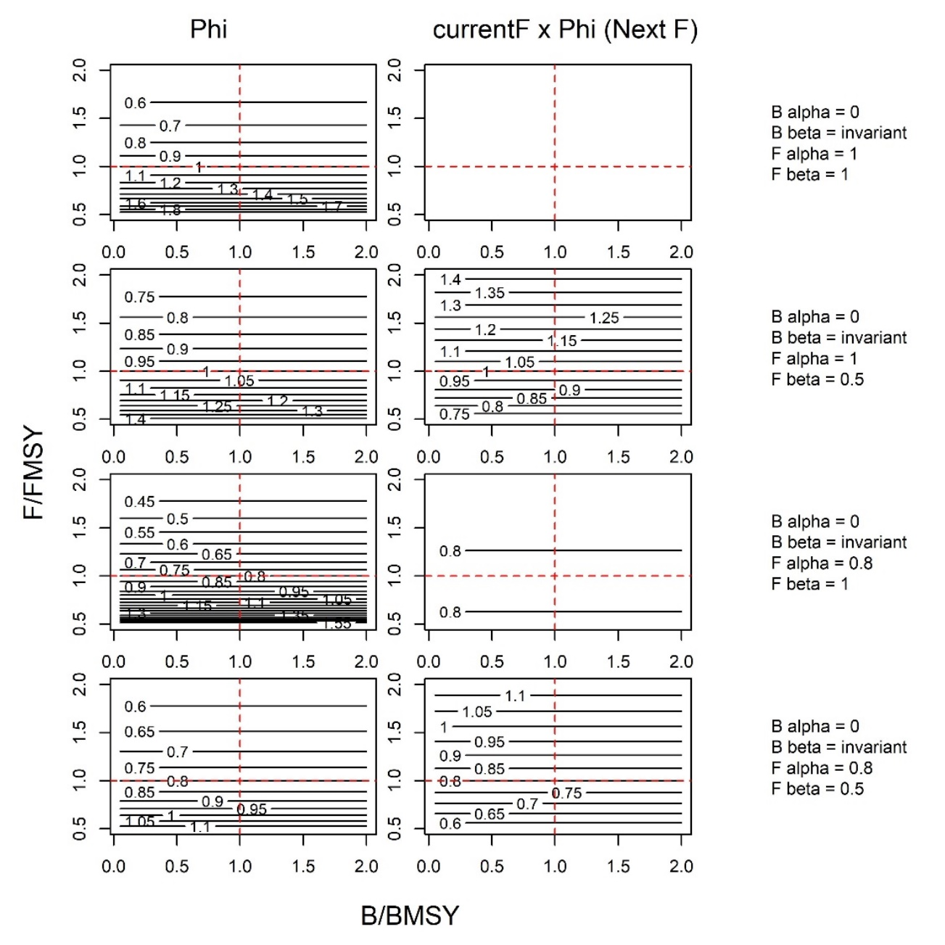

**Figure 1**. MP TAC adjustment based only on current fishing rate relative to FMSY ( only).

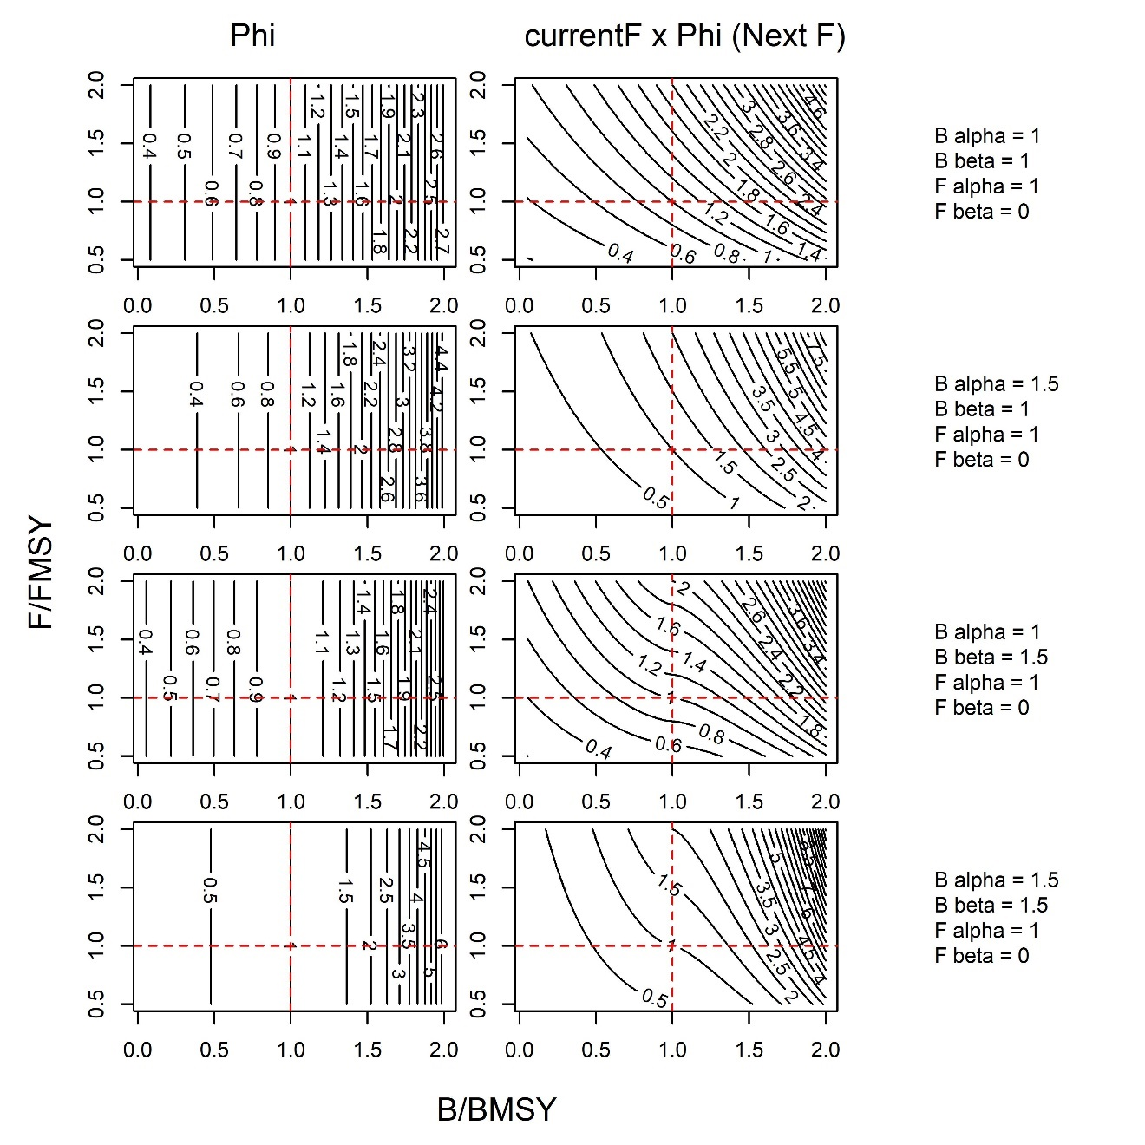

**Figure 2**. MP TAC adjustment based only on current biomass rate relative to BMSY ( only).

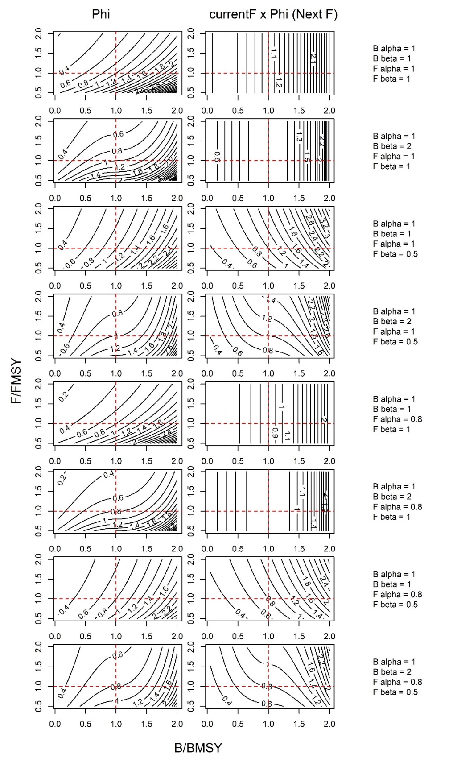

**Figure 3**. MP TAC adjustment using current estimates of biomass and fishing mortality rate relative to MSY levels ( and , respectively). Highlighted in red is the FMSY-BMSY TAC adjustment harvest control rule incorporated into MPx.

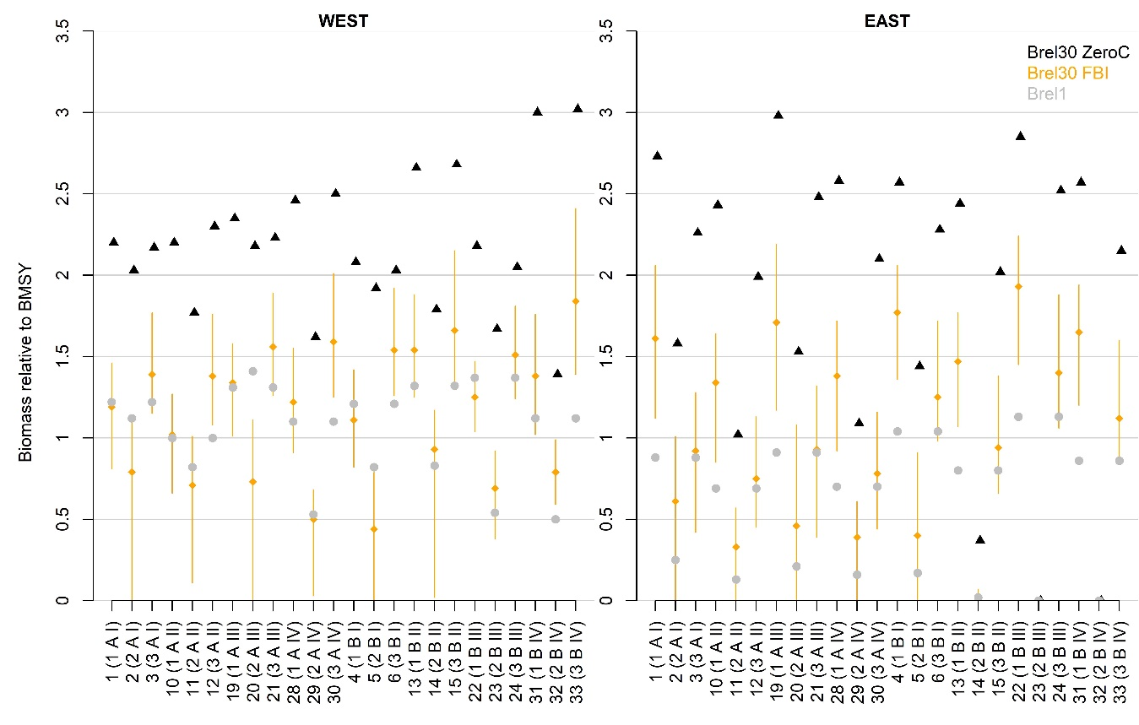

**Figure 4**. Biomass relative to dynamic BMSY for the FBI CMP over all 24 operating models under stochastic simulation conditions. Brel1 is the biomass relative to dynamic BMSY in the first year (not yet under MP control). Orange points and whiskers are the 50th, 5th and 95th percentiles for the FBI CMP, respectively.

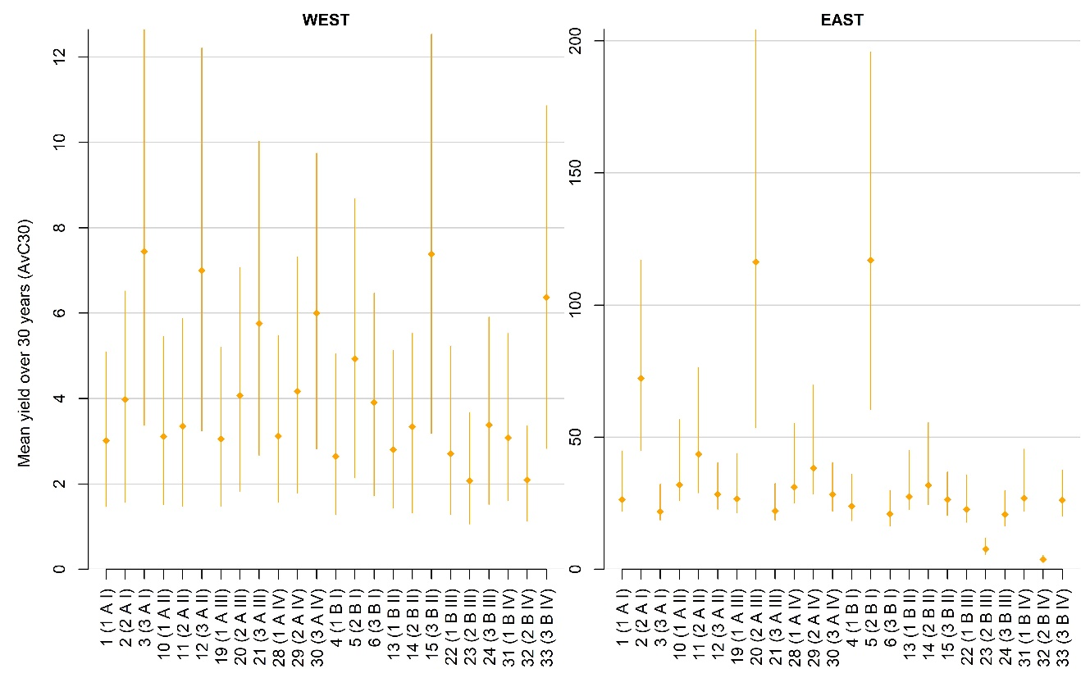

**Figure 5.** Mean yield over the first 30 years of the projection (AvC30) for the FBI CMP over all 24 operating models with stochastic simulations. Orange points and whiskers are the 50th, 5th and 95th percentiles, respectively.

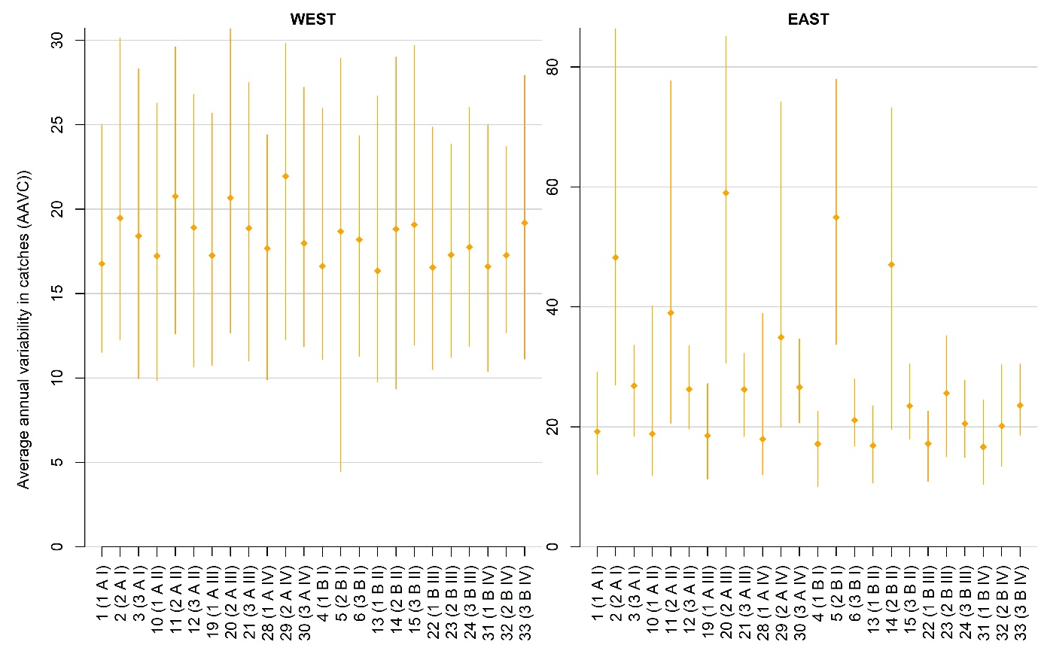

**Figure 6**. Average annual variability in yield (%, median of |yield(y)-yield(y-1)|/yield(y-1) ) the first 30 years of the projection (AAVC) for the FBI CMP over all 24 operating models with stochastic simulations. Orange points and whiskers are the 50th, 5th and 95th percentiles, respectively.

1. Institute for the Oceans and Fisheries. University of British Columbia. [t.carruthers@oceans.ubc.ca](mailto:t.carruthers@oceans.ubc.ca). +1 604 822 6903